|  |  |
| --- | --- |
| Assignment date | 12/10/2022 |
| Name | Ishwarya M |
| Team ID | PNT2022TMID04956 |
| Maximum Marks | 2 Marks |

**ASSIGNMENT 3**

# Importing required lib.

import cv2  
import numpy as np  
import matplotlib.pyplot as plt

# Create black image

img1 = np.zeros((400,600,3),np.uint8)  
plt.imshow(img1)

<matplotlib.image.AxesImage at 0x7fc494447490>

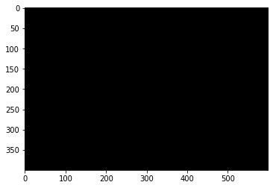

# Drawing functions

# Drawing circle  
  
circle = cv2.circle(img1,(300,200),50,(255,0,0),-1) #(0,0,0)-->(R,G,B)  
plt.imshow(img1)

<matplotlib.image.AxesImage at 0x7fc494252ad0>

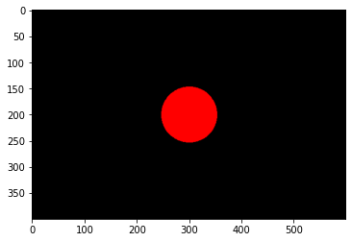

# Drawing rectangle  
  
rectangle = cv2.rectangle(img1,(200,100),(400,300),(0,255,0),5)  
plt.imshow(img1)

<matplotlib.image.AxesImage at 0x7fc4941d9fd0>

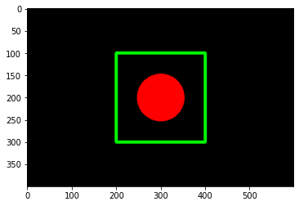

# Drawing lines  
  
line1 = cv2.line(img1,(200,100),(400,300),(0,0,255),5)  
line2 = cv2.line(img1,(400,100),(200,300),(0,0,255),5)  
circle = cv2.circle(img1,(300,200),50,(255,0,0),-1)  
plt.imshow(img1)

<matplotlib.image.AxesImage at 0x7fc494055210>

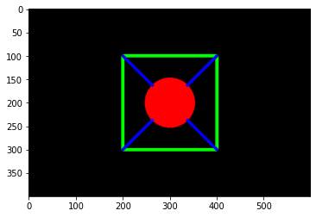

# Writing text on image  
  
text = cv2.putText(img1,'OpenCV',(200,50),cv2.FONT_HERSHEY_SIMPLEX,2,(255,255,255),5)  
plt.imshow(img1)

<matplotlib.image.AxesImage at 0x7fc4940b4550>

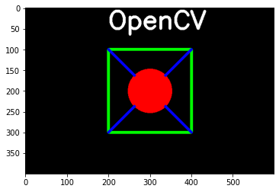

# Save the image  
  
cv2.imwrite('output.jpg',img1)

True

# Reading the image  
  
img = cv2.imread('/content/cat.jpg')  
plt.imshow(img)

<matplotlib.image.AxesImage at 0x7fc4935bfe10>

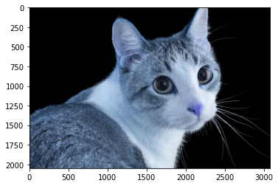

# Coverting color (BGR to RGB)  
  
img_rgb = cv2.cvtColor(img,cv2.COLOR_BGR2RGB)  
plt.imshow(img_rgb)

<matplotlib.image.AxesImage at 0x7fc4935431d0>

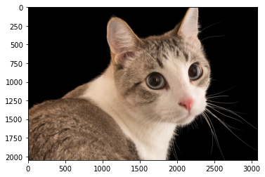

# Coverting color (BGR to Gray)  
  
img_gray = cv2.cvtColor(img,cv2.COLOR_BGR2GRAY)  
plt.imshow(img_gray)

<matplotlib.image.AxesImage at 0x7fc492cd9650>

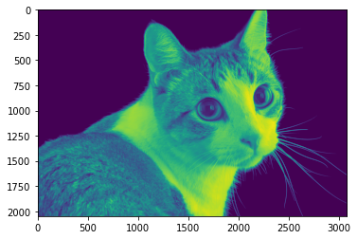

# Visualizing the shape  
  
img_rgb.shape

(2048, 3072, 3)

# Reshape image  
  
img_resize = cv2.resize(img_rgb,(500,400))  
plt.imshow(img_resize)

<matplotlib.image.AxesImage at 0x7fc492cb5050>

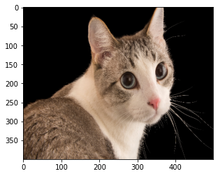

# Rotate image  
  
img_rotate = cv2.rotate(img_resize,cv2.ROTATE_90_CLOCKWISE)  
plt.imshow(img_rotate)

<matplotlib.image.AxesImage at 0x7fc492c0c650>

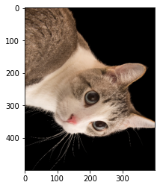

# Image crop  
  
img_crop = img_resize[175:220,250:300]  
plt.imshow(img_crop)

<matplotlib.image.AxesImage at 0x7fc48a417390>

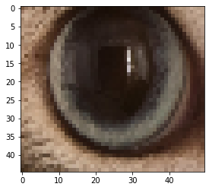

# Image Blur  
  
img_blur = cv2.GaussianBlur(img_resize,(11,11),cv2.BORDER_ISOLATED)  
plt.imshow(img_blur)

<matplotlib.image.AxesImage at 0x7fc48a21c490>

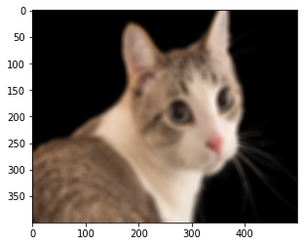

# Creating Border  
  
im=cv2.copyMakeBorder(img_crop,5,5,10,10,cv2.BORDER_CONSTANT)  
plt.imshow(im)

<matplotlib.image.AxesImage at 0x7fc48a1fb4d0>

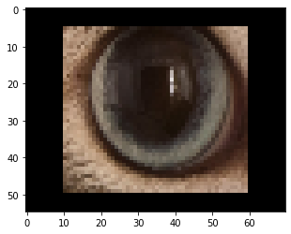

# Edge detection  
  
img_canny = cv2.Canny(img_resize,20,20)  
plt.imshow(img_canny)

<matplotlib.image.AxesImage at 0x7fc489fb9d90>

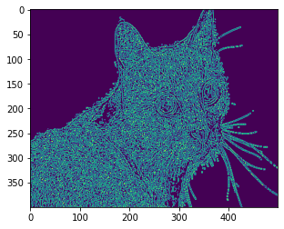

# Edge detection  
  
img2 = cv2.imread('/content/Hyundai_KONA-EV_Side-Profile_640x331.png')  
img2_canny = cv2.Canny(img2,150,150)  
plt.imshow(img2_canny)

<matplotlib.image.AxesImage at 0x7fc48a0e3050>

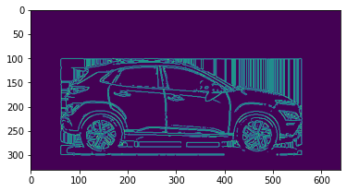

plt.imshow(img2)

<matplotlib.image.AxesImage at 0x7fc48a4dba10>

